Artificial intelligence in interdisciplinary higher education: A systematic review on opportunities, challenges and future directions

Qi Xia
Zhejiang University, China

Zili Zhang
Pennsylvania State University, United States

Taiqi Xing
Zhejiang University, China

Branko Andic
Johannes Kepler Universität Linz, Austria

Thomas K. F. Chiu
The Chinese University of Hong Kong, Hong Kong SAR, China

As artificial intelligence (AI) becomes increasingly embedded in higher education, it is simultaneously transforming how interdisciplinary education is conceived, delivered and evaluated. This study presents a systematic review of 59 recent studies to investigate the evolving relationship between AI and interdisciplinary education in higher education. Guided by four research questions, we examined (a) the forms of interdisciplinary education emerging in the AI context; (b) the main research focuses within this intersection; (c) the functional roles AI plays in interdisciplinary settings; and (d) the impact of AI on different educational stakeholders. Findings indicate that AI-supported interdisciplinary education includes the integration of science, technology, engineering and mathematics (STEM) and science, technology, engineering, art and mathematics (STEAM); non-STEM applications; cross-disciplinary curricula; and diverse student backgrounds. The literature search identified three primary research focuses: AI system and tool development, AI-empowered curriculum transformation and AI-based learning analysis and evaluation. Functionally, AI acts as an evaluator, agent, monitor and assistant, reshaping how knowledge is constructed and assessed across disciplines. Finally, this study developed an interdisciplinary human-AI interactive learning model, providing a conceptual reference framework for AI-supported interdisciplinary teaching and outlining five directions for future research. This review offers critical insights for researchers, educators and policymakers seeking to navigate the challenges and opportunities at the intersection of AI and interdisciplinary higher education.

Implications for practice or policy:
- Course instructors can embed AI-supported activities that promote interdisciplinary problem-solving.
- Institutions should establish policies on AI ethics, bias, transparency and student data privacy.
- Educators need sustained training to build practical AI literacy.
- Policymakers should ensure equitable access to AI tools for all learners.
- Programmes should align AI use with sustainability and global citizenship goals.

Keywords: artificial intelligence (AI), interdisciplinary education, higher education, systematic review

Introduction

Interdisciplinary education in higher education is an instructional paradigm that transcends traditional disciplinary boundaries, integrating knowledge, methods and epistemologies from multiple fields to address complex, real-world challenges (Cai et al., 2025). With the rising intricacy of global issues, the need for learners who can navigate and synthesise knowledge across domains has become increasingly urgent. Interdisciplinary education cultivates such competencies, equipping students with the ability to think critically across disciplines and apply integrated knowledge to solve multifaceted problems (Spelt et al., 2009). As such, it is vital to enhancing educational quality, fostering innovation and preparing students for diverse professional futures (Markauskaite et al., 2024).

Artificial intelligence (AI) refers to digital systems that simulate human cognitive functions such as learning, reasoning and language processing (Banh & Strobel, 2023; Haenlein & Kaplan, 2019). AI has emerged as a transformative force in this context, both enabling and reshaping interdisciplinary teaching and learning in higher education. AI technologies offer personalised learning experiences, expanded access to educational resources and advanced platforms for integrating cross-domain knowledge (Bond et al., 2024; Chiu et al., 2023; Xia et al., 2024; Xia et al., 2025). However, integrating AI into interdisciplinary education often requires navigating complex technological infrastructures, managing heightened cognitive demands, addressing methodological inconsistencies and confronting ethical concerns such as data privacy and algorithmic bias. For example, while the development of AI has provided a broader range of technological options and AI is expected to play an increasingly significant role in interdisciplinary teaching and learning processes (Cai et al., 2025), teachers and students often lack the knowledge to select the most suitable AI tools for their specific needs to enhance teaching and learning efficiency. These limitations underscore the need for a more nuanced understanding of how AI functions in interdisciplinary contexts, particularly regarding its pedagogical roles and effects on learning processes.

Recent reviews have highlighted AI's role in adaptive systems, personalisation (Bond et al., 2024; Yusuf et al., 2024) and its applications in interdisciplinary learning through models, robots, systems and frameworks (Cai et al., 2025), with noted impacts on learning outcomes, argumentation, experience and teaching. However, key gaps remain: (a) limited understanding of AI's support across different interdisciplinary models (e.g., science, technology, engineering, art and mathematics [STEAM] vs non- STEM [science, technology, engineering and mathematics]); (b) lack of holistic analysis of AI's influence on curriculum, interaction and assessment (Heeg & Avraamidou, 2023); (c) fragmented discussion on AI's functional roles (Caratozzolo et al., 2022; Schmitt & Beneder, 2024); and (d) insufficient attention to stakeholder-specific impacts on cognitive and behavioural dimensions (Spelt et al., 2009).

To address these gaps, this systematic literature review aimed to synthesise and critically analyse current research on AI-supported interdisciplinary education in higher education, while advancing conceptual development by attempting to construct an interdisciplinary learning model suited to human-AI collaborative contexts. Specifically, it is guided by the following research questions (RQs):

- RQ1: In the context of AI, in what forms is interdisciplinary education conducted in higher education?
- RQ2: What are the main research focuses of interdisciplinary education in higher education under the AI context?
- RQ3: What roles does AI play in interdisciplinary education in higher education, and what are its effects?
- RQ4: How does AI impact different stakeholders in higher education?

Methodology

Literature search

This study followed the PRISMA 2020 guidelines (Page et al., 2021) to ensure transparency and rigor. The search strategy, informed by previous reviews (Bond et al., 2024; Cai et al., 2025; Zawacki-Richter et al., 2019), was conducted in January 2025, across Web of Science, Scopus, ERIC, ProQuest and PsycINFO. The full search strings are presented in Table 1. Concepts such as multidisciplinary, interdisciplinary, cross-disciplinary and transdisciplinary learning are closely related, although scholars distinguish them by varying degrees of integration and boundary crossing (Davies et al., 2010; Stember, 1991). In practice, however, these distinctions often blur in educational contexts, where interactions among multiple disciplines rarely align neatly with theoretical categories. Therefore, this review adopted a broader usage of interdisciplinary to refer generally to dialogue or interaction among two or more disciplines (Moran, 2010, pp. 13–16).

Table 1
Search strings
AI | Interdisciplinary | Higher education
AI OR GenAI OR “generative AI” OR “generative artificial intelligence” OR “Large Language Model” OR LLMs OR ChatGPT OR GPT OR Chatbot OR Claude OR “Deep learning” OR “virtual assistants” OR “natural language processing” OR NLP OR “learning analytics” | interdisciplinary OR cross-disciplinary OR multidisciplinary OR “multiple disciplines” OR trans-disciplinary OR transdisciplinary OR “hybrid disciplines” OR STEAM OR STEM | “higher education” OR university OR college OR undergraduate OR graduate OR  “tertiary education” OR “post-secondary education” OR postgrad* OR “university student” OR “graduate education” OR “graduate school”

Inclusion and exclusion criteria and screening

A total of 2,950 records were retrieved (see Figure 1) and imported into EndNote 21 for management. Following both automated and manual deduplication, 666 duplicates were removed, resulting in 2,284 articles for title and abstract screening. All of us collaboratively screened an initial set of 75 records to ensure coding consistency. The remaining articles were independently screened by the first two of us, with the third conducting verification. After excluding 1,976 articles, 308 full-text articles were assessed for eligibility, of which 249 were excluded. Ultimately, 59 studies met the criteria and were included in the final review. The inclusion and exclusion criteria are as shown in Table 2.

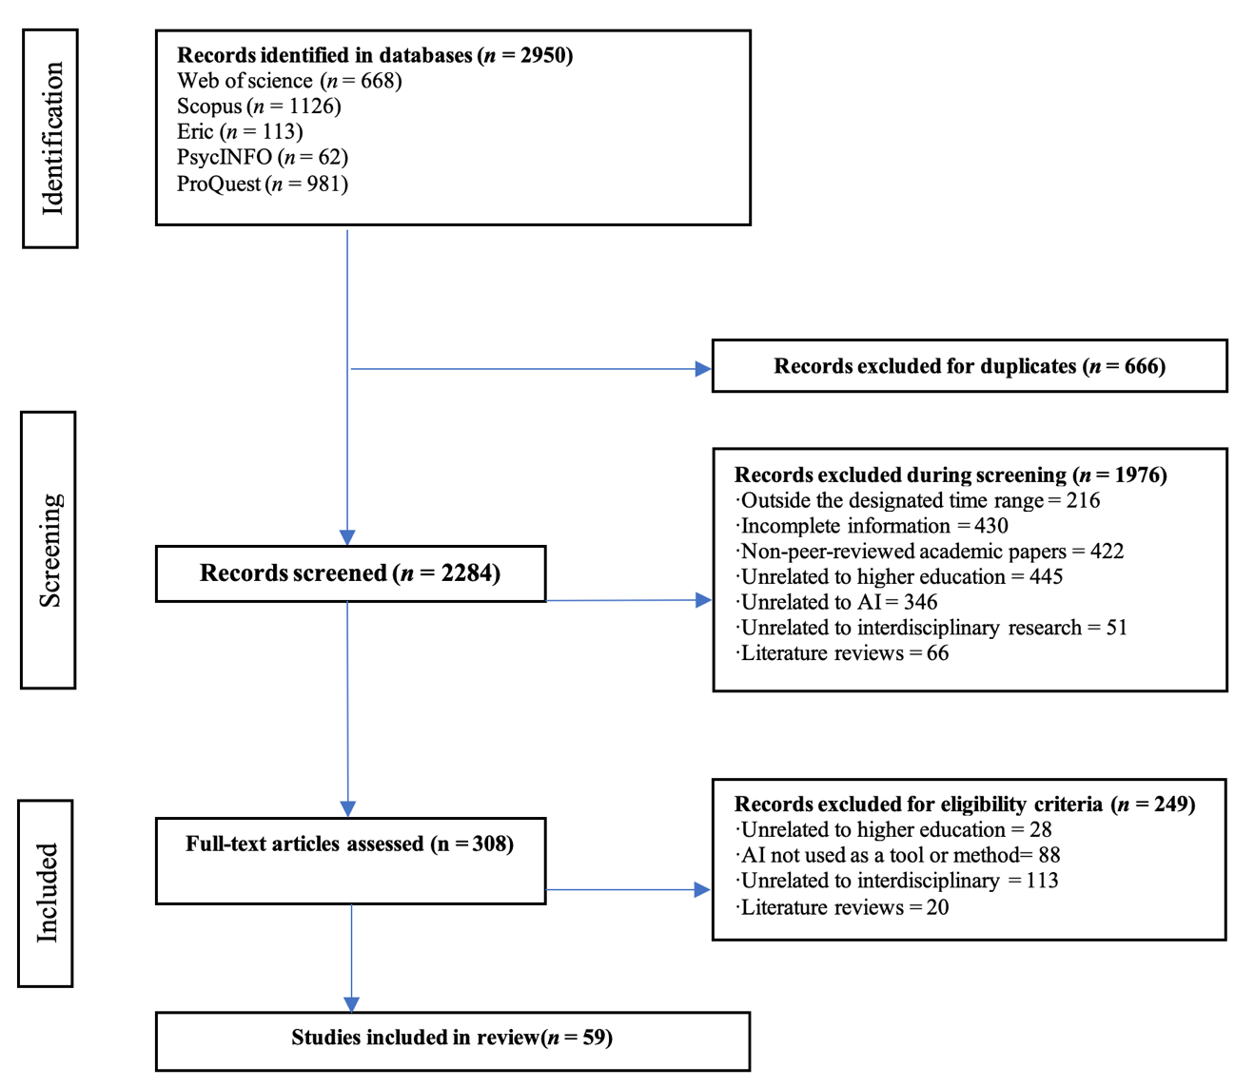
Figure 1. Study selection process

Table 2
Inclusion and exclusion criteria
Inclusion criteria | Exclusion criteria
The research subjects and domains pertain to higher education. | Studies focusing on K–12, special education or other non-higher education contexts are excluded.
The studies should report the application of AI technologies in educational contexts. | Some studies present AI as a learning topic rather than a teaching tool in interdisciplinary education.
The research topic must fall within the scope of interdisciplinary domains. | Articles that discuss the relationship between AI and education but do not engage with the topic of interdisciplinary education are excluded.

Quality evaluation

This review included quantitative, qualitative and mixed methods studies; accordingly, a hybrid quality assessment framework was developed by integrating standards from both paradigms. Drawing on the medical education research study quality instrument and previous studies (Hooshyar et al., 2024), six evaluation criteria were applied to each study type. Each criterion was scored from 0 (not mentioned) to 3 (well addressed). A total of 59 studies were assessed, with scores ranging from 8 to 15 (see the Appendix). No studies were excluded based on quality scores.

Data coding

We (the first three of us authors: two independent coders and one moderator) collaboratively conducted the data coding. A coding framework was developed and refined through a pilot test on 20 articles, drawing on established classification approaches (Cai et al., 2025; Xia et al., 2025; Xia et al., 2026). Coding was conducted collaboratively by the three of us; ambiguities were resolved through discussion, with unresolved cases adjudicated by the last of us authors. Final results were compiled in a structured table (see Table 3), with an inter-coder reliability of 0.85.

Table 3
Coding results (N = 59)
Author (year) | Regionª | Interdisciplinary form^{b} | AI form^{c} | Role of AI^{d} | Research focus^{e} | Impacted object^{f} | Impacted dimension^{g}
Adeika et al. (2024) | USA | STEM | TEF | EVL, AST | CTT | TCR | BHV
Akser et al. (2017) | UK | STEAM | EDU | AST | TSD | STU, TCR | COG, BHV, EMO
Akula et al. (2024) | India | NS, CSB | EDU | AGN, AST | CTT | STU | COG, BHV, EMO
Alenezi (2024) | Spain | IS, CSB | EDU, TEF | EVL, AGN, MNT, AST | ALE | STU, TCR, SAF | COG, BHV, EMO
Algahtani (2024) | Saudi Arabia | IS | EDU | EVL, AGN, MNT, AST | ALE | STU, TCR, SAF | COG, BHV, EMO
Ali et al. (2023) | Germany | STEM | EDU | AGN | TSD | STU | COG, BHV, EMO
Almahdi & Sharef (2023) | Bahrain | STEM | EDU | MNT | ALE | STU | BHV
Ayanwale (2024) | South Africa | CSB | GRL | MNT | ALE | STU | COG, BHV
Baghel et al. (2024) | USA | CSB | GRL | AGN | ALE | TCR | COG, BHV
Bertolini et al. (2023) | USA | STEM | TEF | EVL | ALE | TCR | COG, BHV
Borges et al. (2024) | Switzerland | STEM | EDU | EVL, AST | ALE | STU, TCR | COG, BHV
Calderón et al. (2024) | Spain | STEM | EDU | EVL, MNT, AST | TSD | STU, TCR | COG, BHV
Caratozzolo et al. (2022) | Mexico | STEM | EDU | EVL | CTT | STU | COG, BHV
Chen et al. (2023) | USA | NS | EDU | AGN | CTT | STU, TCR | COG, BHV, EMO
Chen et al. (2024) | Mainland China | CLC | GRL | AST | CTT | STU, TCR | COG, BHV
Chiang (2021) | Taiwan | IS | EDU | EVL, AST | TSD | STU | COG, BHV
Chu & Liu (2024) | Mainland China | NS | GRL | AST | CTT | STU, TCR | COG, BHV
Chun & Elkins (2023) | USA | NS | GRL | AST | ALE | STU | COG, BHV
Deng et al. (2024) | Mainland China | CLC | GRL | AST | CTT | STU, TCR, SAF | COG, BHV
Eaton (2017) | USA | CSB | RBT | AGN, AST | TSD | STU | COG, BHV
Fareed et al. (2024) | UAE | CSB, CLC | GRL | AST | TSD | STU | COG, BHV
Feng & Magana (2021) | USA | STEM | EDU | AGN | TSD | STU | COG
Hsu et al. (2025) | Taiwan | IS, CSB | EDU | AGN, AST | CTT | STU, TCR | COG, BHV, EMO
Jendreiko (2024) | Germany | IS, CSB, CLC | EDU | AST | CTT | STU | COG, BHV, EMO
Ji et al. (2024) | Mainland China | STEM | GRL | AST | ALE | STU | COG
Kalthoff et al. (2022) | Germany | CSB | TEF | EVL, AST | CTT | STU | COG, BHV
Kamukapa et al. (2024) | South Africa | NS | GRL | EVL | CTT | STU, TCR, SAF | COG, BHV
Keating (2019) | USA | STEAM, CSB, CLC | EDU, RBT | AGN, MNT, AST | CTT | STU | COG, EMO
Khan et al. (2020) | USA | STEM | TEF | AST | CTT | STU | COG, BHV
Khan et al. (2020) | USA | STEM | TEF | AST | CTT | STU | COG, BHV
Kovari et al. (2024 | Hungary | CLC | GRL | AST | CTT | STU | COG
Lee (2023) | USA | STEM | TEF | AST | ALE | STU, TCR | BHV
Lee et al. (2021) | USA | STEM | RBT | AGN, AST | ALE | STU | BHV
Li (2017) | Macao SAR | NS | GRL | AST | CTT | STU, TCR | BHV
Li (2021) | Mainland China | NS | EDU | EVL, AST | TSD | STU, TCR | BHV
Li, Lloyd et al. (2023) | USA | STEM | TEF | EVL | TSD | STU, TCR | COG
Li, Wang et al. (2023) | USA | STEM | EDU | AST | CTT | STU | COG
Lin et al. (2021) | Taiwan | STEM | EDU | MNT, AST | CTT | STU | COG, BHV, EMO
Loukatos et al. (2022) | Greece | STEM | RBT | AST | CTT | STU | COG
Lünich et al. (2024) | Germany | IS | EDU | EVL, AST | ALE | STU | COG, BHV, EMO
McInnis-Dominguez (2023) | USA | NS, CSB, CLC | GRL | AST | ALE | STU | COG, BHV
Mehrabi et al. (2024) | Iran | STEM | TEF | AGN | CTT | STU, TCR | BHV
Menkhoff & Teo (2022) | Singapore | NS | RBT | AST | CTT | STU | COG
Miao et al. (2020) | Mainland China | STEM | TEF | EVL | ALE | STU, TCR | BHV
Okoye & Ja (2024) | USA | STEM | EDU | EVL, MNT, AST | TSD | STU | COG, BHV
Oprea (2020) | Romania | STEM | EDU, TRF RBT | AST | TSD | STU | COG, BHV
Ortega et al. (2024) | USA | STEM | EDU | EVL, AGT | ALE | STU | COG, BHV
Orthaber et al. (2020) | Austria | STEM | TEF | EVL | TSD | STU, TCR | BHV
Ou (2024) | Mainland China | NS | GRL | AST | ALE | STU | COG
Phummapooti et al. (2024) | Thailand | CLC | TEF | AST | ALE | STU | BHV
Pupic et al. (2023) | Canada | IS | EDU | MNT, AST | CTT | STU, TCR | COG, BHV, EMO
Stadelmann et al. (2021) | Switzerland | CLC | EDU | AST | CTT | STU, TCR | COG
Su (2022) | Taiwan | CLC | EDU, RBT | EVL, AST | CTT | STU | COG
Tan & Lim (2023) | Malaysia | STEM | TEF | EVL | ALE | STU, TCR | COG, BHV
Xiang et al. (2024) | Mainland China | CSB | EDU | AST | ALE | STU | COG, BHV
Yao et al. (2020) | Taiwan | STEM | RBT | AST | TSD | STU | COG, BHV, EMO
Yu & Yang (2024) | Mainland China | STEM | TEF | EVL | ALE | STU | COG
Zhong et al. (2024) | Singapore | CSB | GRL | AST | CTT | STU | COG
Zönnchen et al. (2024) | Germany | STEM | EDU, TEF | EVL, AST | CTT | STU | COG, BHV
ªUSA: United States of America; UK: United Kingdom; UAEL United Arab Emirates; Macao SAR: Macau Special Administrative Region.
^{b}STEM; STEAM; NS: non-STEM; IS: inter-STEM; CSB: cross-disciplinary student backgrounds; CLC: cross-disciplinary learning content.
^{c}GRL: general AI; EDU: educational AI; TEF: technical framework; RBT: robot.
^{d}EVL: evaluate; AGN: agent; MNT: monitor; AST: assistant.
^{e}TSD: AI tools and system development; CTT: AI-empowered curriculum and teaching transformation; ALE: the application of AI in learning analysis and educational evaluation.
^{f}STU: student; TCR: teacher; SAF: staff.
^{g}COG: cognition; BHV: behaviour; EMO: emotion.

Results

RQ1: In the context of AI, in what forms is interdisciplinary education conducted in higher education?

Six forms of interdisciplinary education were identified, as shown in Figure 2. Within STEM (n = 26), intelligent tutoring systems and AI-driven models enhanced understanding in domains such as electrical circuits and biology by linking engineering, physics and data science (Bertolini et al., 2023; Feng & Magana, 2021). Computer vision and personalised learning platforms further supported adaptive, experiment-based instruction across STEM disciplines (Adeika et al., 2024; Ali et al., 2023), while AI tools such as ChatGPT were integrated into teacher training alongside cultural themes and hardware design to promote interdisciplinary pedagogy (Ji et al., 2024).

Firstly, within STEAM (n = 2), arts integration into AI-related education combined technical skills with human-centred inquiry. For example, SceneMaker, an AI-based storytelling platform, engaged students in computing, drama and music, linking emotional expression with technical design (Akser et al., 2017). Similarly, Carnegie Mellon's AI and Humanity course integrated robotics with philosophy, literature and ethics to examine AI's social implications (Keating, 2019).

Secondly, within non-STEM fields (n = 10), AI advanced interdisciplinary teaching and curriculum innovation towards social and cultural goals. In journalism, AI-driven storytelling frameworks promoted data literacy with attention to ethics and communication (Chen et al., 2023). In design, machine learning analysed cultural motifs to inform curriculum reform in ethnic minority regions (Chu & Liu, 2024). Public administration integrated AI for digital governance education and the reduction of the digital divide (Kamukapa et al., 2024), while theatre education adopted mobile AI tools to enrich performance-based learning (Li, 2017).

Thirdly, within inter-STEM education (n = 8), AI integrated multiple STEM domains to foster system-level thinking and ethical awareness. Studies have demonstrated technical integration through smart home modules, natural language processing-supported mathematics assessments and adaptive e-notebooks that connected engineering content with learning theory (Okoye & Ja, 2024; Tan & Lim, 2023; Yao et al., 2020). Other research has emphasised ethical and human-centred considerations, examining fairness in AI prediction systems, radiology training aligned with policy and evaluations of AI tools in terms of interface, pedagogy and ethics (Lünich et al., 2024; Pupic et al., 2023; Algahtani, 2024). Project-based learning further linked AI, robotics, mechatronics and design thinking to support collaboration and innovation (Hsu et al., 2025; Schmitt & Beneder, 2024).

Fourthly, within cross-disciplinary student backgrounds (n = 14), AI education integrated diverse disciplines that shape students' engagement and understanding. STEM and non-STEM students have shown different adoption patterns (Ayanwale, 2024), and subfields affected how gender bias appears in reflective writing (Baghel et al., 2024). At the curricular level, programmes have accommodated heterogeneous cohorts, including healthcare, law, informatics and speech therapy (Kalthoff et al., 2022) and mixed groups in business, humanities, science and engineering engaging in AI ethics debates (Zhong et al., 2024). Furthermore, cross-field collaboration and peer learning have strengthened AI literacy and research application (Alenezi, 2024; Xiang et al., 2024).

And lastly, within cross-disciplinary content (n = 10), AI integrated learning across domains to promote synthesis and practice-oriented learning. For example, ChatGPT has facilitated projects combining finance, mathematics and programming (Chen et al., 2024) and has enhanced nuclear medicine education by connecting biology, chemistry, ethics and clinical practice (Deng et al., 2024). Similarly, real-world AI applications like facial recognition have promoted scientific reasoning and technological literacy (Su, 2022).

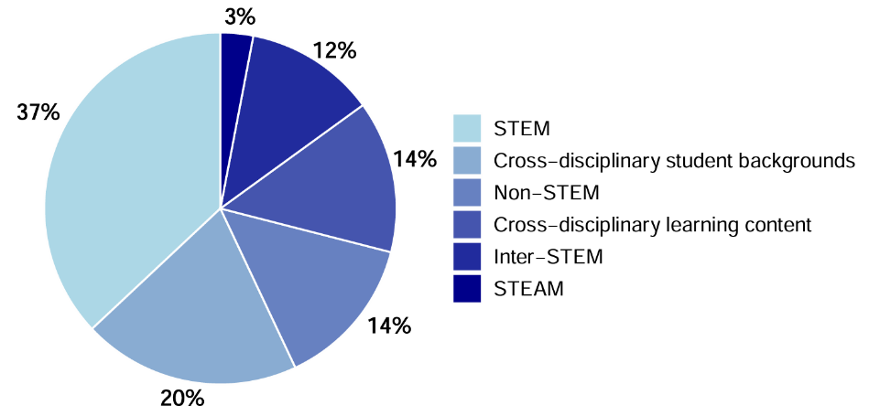
Figure 2. Interdisciplinary education in higher education

RQ2: What are the main research focuses of interdisciplinary education in higher education under the AI context?

As shown in Figure 3, a central focus of interdisciplinary AI research in higher education is the development of customised AI tools and platforms (n = 14). One theme advanced intelligent instructional and assessment systems, including teaching platforms, automated constructed-response assessment models, algorithmic grading systems and hybrid evaluation frameworks based on the Internet of Things and deep learning (Li, 2021; Li, Wang et al., 2023; Orthaber et al., 2020). A second theme focused on applied system design, such as robotics-based instruction, robot operating system-supported AI engineering courses and edge-based AI platforms (Eaton, 2017; Oprea, 2020; Schmitt & Beneder, 2024). A third theme developed domain-specific tools, including AI-generated imagery in architectural education, adaptive e-notebooks and predictive assessment platforms like Codex (Calderón et al., 2024; Fareed et al., 2024; Okoye & Ja, 2024).

Within curriculum and pedagogy, AI has driven interdisciplinary transformation to foster ethical, practical and cross-disciplinary competencies (n = 25). Studies have shown that AI supports project-based and hands-on learning across multiple fields, including engineering, STEM education, agriculture and the arts, while encouraging sustainability and ethical reflection (Jendreiko, 2024; Khan et al., 2020; Kovari et al., 2024; Lin et al., 2021; Loukatos et al., 2022). Moreover, AI has reshaped teaching through personalised delivery, natutal language processing-based competency assessment, AI-supported classroom observation and hybrid learning models that promote critical engagement with AI's societal role (Adeika et al., 2024; Caratozzolo et al., 2022; Mehrabi et al., 2024; Stadelmann et al., 2021).

Within learning analytics and educational evaluation, AI has supported predictive modelling and assessment redesign to enhance academic support and personalisation (n = 20). Much of the research has focused on prediction, using machine learning to forecast performance, detect at-risk students, identify key graduation courses and guide the selection of majors (Almahdi & Sharef, 2023; Lee, 2023; Ortega et al., 2024; Phummapooti et al., 2024). Other studies have extended this support through conversational AI for advising and career planning, as well as engagement detection tools for real-time analytics (Lee et al., 2021; Yu & Yang, 2024). At the same time, some scholars have critically examined AI's pedagogical and evaluative implications, integrating it into digital humanities and questioning its performance on standardised assessments (Borges et al., 2024; Chun & Elkins, 2023; McInnis-Dominguez, 2023).
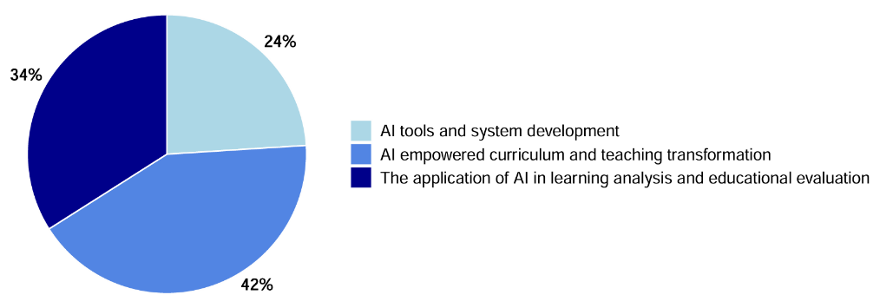
Figure 3. Interdisciplinary research focuses in higher education

RQ3: What roles does AI play in interdisciplinary education in higher education, and what are its effects?

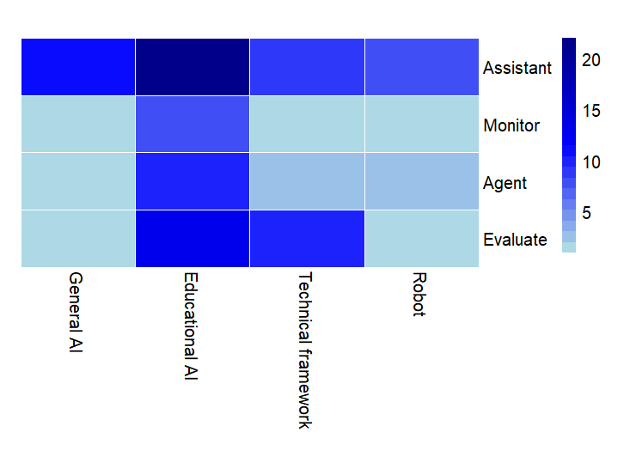
Figure 4. Role of AI in facilitating interdisciplinary education

As shown in Figure 4, studies have positioned AI as evaluators (n = 22):

- Evaluating interdisciplinary education with general AI (n = 1): Kamukapa et al. (2024) offered a a curriculum-level evaluation approach to diagnose missing interdisciplinary AI preparedness and guide cross-departmental curricular redesign.
- Evaluating interdisciplinary learning with educational AI (n = 13): Studies have shown that AI can enable more efficient, unbiased and comprehensive assessments by capturing both performance and process (Adeika et al., 2024; Caratozzolo et al., 2022) and use performance data to scaffold collaboration, problem-solving and targeted support (Borges et al., 2024; Lünich et al., 2024).
- Evaluating interdisciplinary education with AI-powered frameworks (n = 10): Studies have shown that AI can strengthen interdisciplinary education through personalised, scalable, adaptive assessment and feedback, including predictive analytics for instructional adjustment and automated scoring that captures disciplinary reasoning (Bertolini et al., 2023; Li, Lloyd et al., 2023). Similarly, language- and code-focused systems can grade open-ended work with targeted feedback and detect domain-specific errors, such as programming errors, in real time (Miao et al., 2020; Tan & Kim, 2023).
- Evaluating interdisciplinary learning with AI-powered robots (n = 1): Su (2022) demonstrated a replicable AI-supported project-based learning evaluation model using real-world robots to structure interdisciplinary tasks and triangulate learning through rubric-scored pretest and post-test open-ended assessments, attitude measures and interviews.

Next, studies have positioned AI as agents (n = 14):

- General AI as an agent (n = 1) supported interdisciplinary education by processing diverse student reflections to enhance feedback and reduce bias (Baghel et al., 2024).
- Educational AI as an agent (n = 10) provided adaptive, real-time support tailoring scaffolds to proficiency and sustaining engagement in technical domains (Ali et al., 2023; Feng & Magana, 2021). It also supported complex interdisciplinary workflows such as data handling and storytelling and advanced design thinking through feedback and generative outputs (Chen et al., 2023; Hsu et al., 2025).
- AI as a technical framework (n = 3) leveraged educational data to enable personalised learning and inform delivery decisions (e.g., predicting course modality preferences), integrating diverse disciplinary inputs to support learning across contexts (Alenezi, 2024; Mehrabi et al., 2024).
- AI-powered robots as interactive agents (n = 3) catalysed cross-disciplinary dialogue and prompted ethical, social and cultural reflection alongside technical learning. They also provided interactive guidance aligned with learners' goals and decisions (Keating, 2019; Lee et al., 2021).

Furthermore, studies have positioned AI as monitors (n = 9):

- General AI as monitors (n = 1): Ayanwale (2024) examined cross-disciplinary uptake of AI chatbots by comparing STEM and non-STEM students' adoption drivers, such as relative advantage, compatibility and complexity, through survey-based multi-group modelling, identifying discipline-specific barriers and supports.
- Educational AI as monitors (n = 8): AI monitered learning patterns and used predictive analytics to identify risks and gaps early, enabling timely support for diverse learners (Almahdi & Sharef, 2023; Lin et al., 2021). Interactive systems also provided real-time feedback and guidance during STEM and other cross-disciplinary tasks, enabling instructors to adapt instructional support based on learners' ongoing performance (Lin et al., 2021; Pupic et al., 2023).
- AI as a monitor through technical frameworks (n = 1): AI provided real-time feedback and insights; in Alenezi's (2024) example, machine learning and analytics monitored emotional intelligence and e-learning outcomes to customise support across disciplines.
- AI-powered robots as a monitor (n = 1): Carnegie Mellon University has used robots to monitor student engagement so as to make interdisciplinary learning more interactive and participatory, while prompting cross-disciplinary discussion of AI's ethical and technological impacts (Keating, 2019).

Finally, studies have positioned AI as assistants (n = 43):

- General AI tools like ChatGPT have served as versatile learning assistants (n = 11), generating instructional resources, explanations and personalised feedback while broadening access to cross-disciplinary knowledge that supports creativity and innovation (Chen et al., 2024; Chu & Liu, 2024; Deng et al., 2024). They have also advanced ethical and global aims by making complex concepts accessible and prompting value reflection (e.g., eco-humanism), strengthening collaboration and perspectives for challenges such as sustainability (Kovari et al., 2024).
- Educational AI have acted as an interdisciplinary learning assistant (n = 22) by automating technical work so students can focus on creative, analytical, cross-domain thinking (Akser et al., 2017; Li, Lloyd et al., 2023). Tools blending computing with artistic or non-technical applications have fostered collaboration and creativity, while logic-oriented approaches (e.g., Prolog) have linked formal reasoning with aesthetics (Akser et al., 2017; Jendreiko, 2024). AI has also streamlined literature review and data analysis to support interdisciplinary graduate work (Xiang et al., 2024).
- AI has acted as an interdisciplinary learning assistant through technical frameworks (n = 9) by enabling data-driven, scalable personalisation that supported hands-on application and tailored guidance across domains (Khan et al., 2020; Lee, 2023). For instance, Phummapooti et al. (2024) used machine learning to match students with suitable digital majors based on learning styles. Supporting this, infrastructure for AI-enabled robotics and experimentation has facilitated cross-disciplinary implementation in higher education (Oprea, 2020).
- AI-powered robots have acted as assistants in interdisciplinary learning (n = 8) by providing real-time scaffolds for exploration, data interpretation and complex problem-solving in authentic settings (Loukatos et al., 2022; Yao et al., 2020). Alongside embodied robotics in domains such as smart homes and agriculture, natural language processing-based chatbots have guided experiential workshops and prototyping, sustaining engagement and offering immediate feedback during iterative design (Menkhoff & Lydia, 2022; Yao et al., 2020).

RQ4: How does AI impact different stakeholders in higher education?

As shown in Figure 5, this review first identified studies that revealed AI's impact on students in interdisciplinary education (n = 57):

- From the affect perspective (n = 14), AI tools can elicit motivation, curiosity, anxiety and scepticism, especially when perceived as useful, trustworthy and compatible with learning needs (Ayanwale, 2024; Fareed et al., 2024). Structured AI programmes and interdisciplinary platforms can also reduce anxiety while strengthening confidence, self-efficacy and motivation through applied learning and real-time outcomes (Kalthoff et al., 2022; Schmitt & Beneder, 2024; Zönnchen et al., 2024).
- AI can benefit student behaviour (n = 43) by leveraging behavioural or interaction data (e.g., engagement, decision-making) to predict outcomes, personalise guidance, support early intervention and better align learners' preferences with disciplinary pathways (Almahdi & Sharef, 2023; Ayanwale, 2024; Lee et al., 2021; Li, 2021; Phummapooti et al., 2024). In classroom and hands-on contexts, AI can further strengthen participation and iterative problem-solving through interactive teaching systems programming and engineering feedback tools, and authentic design scenarios (Fareed et al., 2024; Kalthoff et al., 2022; Li, 2017; Miao et al., 2020; Orthaber et al., 2020; Schmitt & Beneder, 2024; Zönnchen et al., 2024). AI also reshapes learning relationships by influencing student strategies and teacher practices, including tutoring and predictive supports and assessment adaptations to generative AI and integrity concerns (Algahtani, 2024; Borges et al., 2024).
- AI can enhance students' cognition (n = 47) by supporting higher-order thinking, problem-solving, and cognitive load management across disciplines, helping learners tackle complex STEM tasks, strengthen scientific reasoning and decision-making and extend creativity and analytical skills (Fareed et al., 2024; Ji et al., 2024; Su, 2022; Yu & Yang, 2024; Zhong et al., 2024; Zönnchen et al., 2024). Adaptive platforms can also promote metacognition and deep engagement via personalised feedback and structured exploration (Calderón et al., 2024; Li, Lloyd et al., 2023; Stadelmann et al., 2021), empowering students and teachers to engage critically with disciplinary knowledge and advanced problem-solving across contexts (Alenezi, 2024; Algahtani, 2024; Ayanwale, 2024; Kalthoff et al., 2022; Schmitt & Beneder, 2024).

This review then identified studies that revealed AI's impact on teachers in interdisciplinary education (n = 26):

- AI integration can shape teachers' affect (n = 7) by influencing trust, confidence and professional pressure, especially when reflective summaries or predictive analytics require teachers to interpret outputs and respond to at-risk flags (Baghel et al., 2024; Bertolini et al., 2023). AI environments can also generate renewed purpose and emotional complexity as educators navigate mentoring opportunities alongside enthusiasm, scepticism and concerns about loss of control or integrity challenges with tools like ChatGPT (Algahtani, 2024; Borges et al., 2024; Schmitt & Beneder, 2024).
- AI can reshape teacher behaviour (n = 24) by shifting educators from knowledge deliverers to adaptive facilitators who use real-time analytics and feedback (e.g., computer vision, e-assessment, explainable AI) to adjust instruction, support formative assessment and automate routine tasks, freeing attention for student-centred learning and higher-order thinking (Adeika et al., 2024; Li, 2017, 2021; Miao et al., 2020; Orthaber et al., 2020). It can also affect classroom dynamics via emotional-intelligence supports in gamified learning and assessment redesigns prompted by generative AI (Alenezi, 2024; Borges et al., 2024).
- AI can enhance teachers' cognition (n = 18) by supporting information processing, instructional customisation, and critical thinking through guided exploration and reflection frameworks and learning analytics that provide real-time progress insights for shared teacher–student decision-making (Algahtani, 2024; Bertolini et al., 2023; Calderón et al., 2024; Schmitt & Beneder, 2024; Stadelmann et al., 2021). AI can further reduce cognitive load and sharpen pedagogical judgment by identifying misconceptions, synthesising reflections and generating actionable indicators for timely feedback and data-informed adjustment, including in interdisciplinary project-based collaboration (Algahtani, 2024; Baghel et al., 2024; Bertolini et al., 2023; Li, Lloyd et al., 2023; Schmitt & Beneder, 2024).

Lastly, this review identified studies that revealed AI's impact on staff in interdisciplinary education (n = 4):

- AI integration can shape staff's affect (n = 2) by automating administrative and library workflows and enabling satisfaction and sentiment monitoring, while change pressures and ethical risks can heighten anxiety and resistance (Alenezi, 2024; Algahtani, 2024).
- AI can reshape staff behaviour (n = 4) by shifting clinical and academic staff towards AI-assisted research and document and assessment production with added verification, prompting curriculum staff to audit programs and pursue AI upskilling and automating routine library work to reallocate effort to higher-value services (Alenezi, 2024; Deng et al., 2024; Kamukapa et al., 2024).
- AI can enhance staff's cognition (n = 4) by boosting sensemaking (rapid literature synthesis and writing support), strengthening governance judgement (ethics and risk evaluation, human oversight of AI outputs and interpretation of analytics/UX evidence) and guiding curriculum and workforce reasoning (mapping AI competencies, diagnosing gaps and targeting upskilling for AI-ready work) (Algahtani, 2024; Deng et al., 2024; Kamukapa et al., 2024).

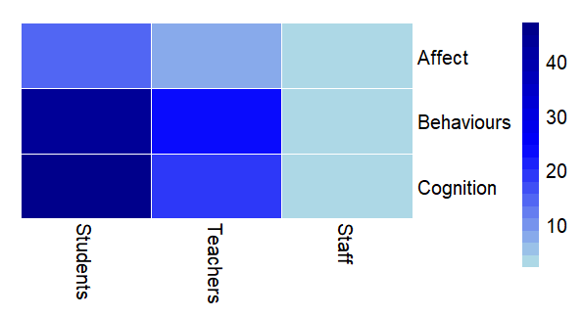
Figure 5. Influences of AI on disciplinary development in higher education

Discussion and conclusion

This study has synthesised how AI is reshaping interdisciplinary education in higher education. First, with regard to RQ1, interdisciplinary learning is shifting towards dynamic, convergence-driven configurations. Second, with regard to RQ2, research increasingly emphasises practical innovations in tools, curricula and assessment, while raising concerns about ethics and equity. Third, with regard to RQ3, AI functions as evaluator, agent, monitor and assistant, reshaping instructional interactions and power dynamics. Fourth, with regard to RQ4, AI affects not only academic outcomes but also learners' cognitive and emotional experiences, underscoring the need for human-centred integration that sustains pedagogical agency.

Despite rapid development, AI-supported interdisciplinary learning research reveals three major challenges. First, interdisciplinary design often lacks depth and contextual grounding. Many studies rely on short interventions, small samples or tasks that do not require genuine interdisciplinary integration, limiting sustained and meaningful learning experiences (Mehrabi et al., 2024; Zhong et al., 2024). Institutional constraints further restrict integration with authentic cultural and industry-linked contexts (Chu & Liu, 2024). Second, AI integration introduces technological, ethical and learner-related risks. Tool-centred studies continue to face issues of accuracy, bias, misuse and immature assessment instruments (Fareed et al., 2024; Feng & Magana, 2021), while AI-computer vision applications raise concerns about privacy and transparency (Adeika et al., 2024). Limited differentiation by AI literacy (Lin et al., 2021) and risks of overreliance or disengagement (Algahtani, 2024; Borges et al., 2024) further complicate implementation. Third, human-centred AI implemented curricular models face challenges of scalability and generalisability. Although they acknowledge emerging AI risks, their reliance on context-specific adaptation limits broader applicability across institutions (Chun & Elkins, 2023).

Based on these findings, we propose an interdisciplinary human-AI interactive learning model to guide balanced and context-sensitive implementation. As illustrated in Figure 6, AI-supported interdisciplinary education can be conceptualised as a distributed human-AI collaboration system structured across four interrelated dimensions:

- Boundary mediation and knowledge integration: At the core of the model, AI supports the progression from interdisciplinary knowledge to thinking and action. By facilitating content integration across varying levels of complexity, AI mediates disciplinary boundaries and enables deeper cognitive expansion beyond single-domain expertise, guiding scaffolded cross-domain learning tasks.
- Role and capability distribution: The framework highlights differentiated AI roles (agent, assistant, evaluator and monitor) that align with task allocation and capability development. This orchestration allows AI to support collaboration and reasoning while preserving meaningful human agency through adaptive task allocation.
- Ethical and equity governance: The outer system layer emphasises balance among efficiency, affective regulation, ethical oversight and capability expansion. This reflects concerns about bias, overreliance and unequal access, suggesting that AI integration must be institutionally guided rather than technologically driven, with embedded monitoring mechanisms.
- Teacher agency and sustainable design: By redistributing cognitive and evaluative functions, the model underscores the need for sustained professional development and co-design practices, ensuring that AI supports long-term curricular goals such as sustainability, inclusion and global responsibility in authentic classroom implementation.

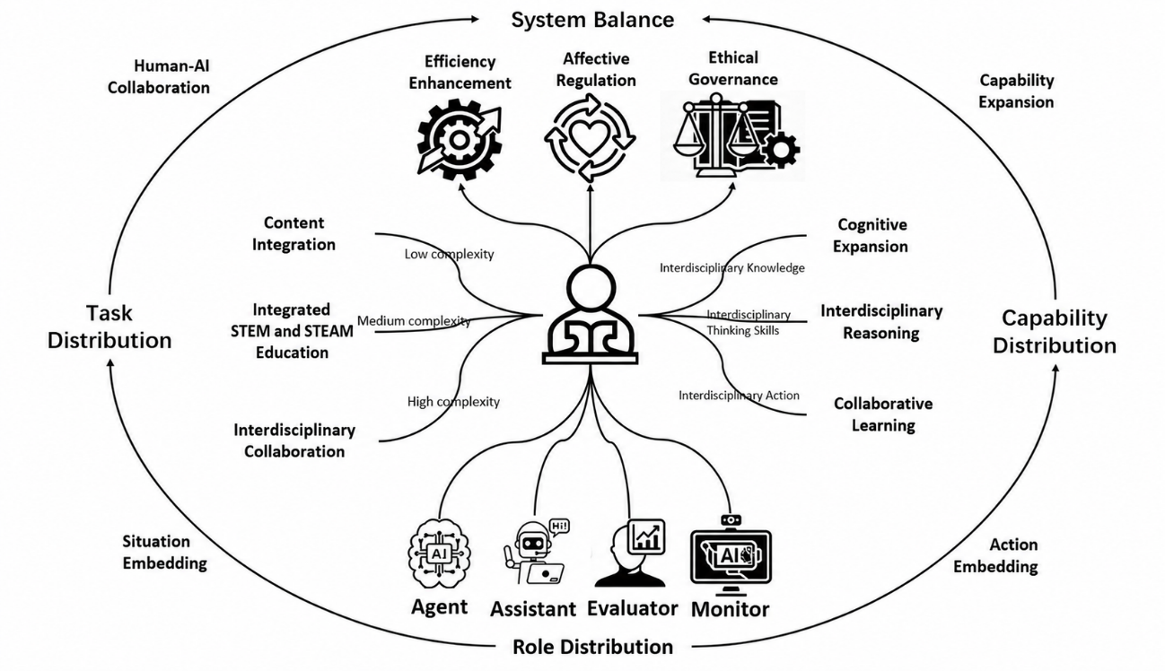
Figure 6. Interdisciplinary human-AI interactive learning model

Limitations and future directions

This study has three limitations. Firstly, the search strategy excluded grey literature and was conducted only once, which may have led to the omission of recent studies in this rapidly evolving field. Secondly, the review did not include meta-analytical procedures or report effect sizes, limiting the practical applicability of the findings. Thirdly, generalisability is constrained by geographic concentration, as most included studies originated from technologically advanced regions, with limited representation from under-resourced educational contexts.

Five key themes emerged from this study:

- AI acts as a mediator of disciplinary boundaries, reshaping curriculum structures, faculty roles and student competencies by enabling both integration and pedagogical differentiation.
- AI integration raises ethical and pedagogical concerns, including bias, overreliance and academic integrity, requiring critical institutional governance.
- Issues of access, digital literacy and equity must be addressed to prevent new disparities in interdisciplinary programmes.
- Teachers' professional development and agency are essential, as educators must move from passive users to active co-designers of AI-supported learning.
- AI integration should align with sustainability, social justice and global citizenship, embedding ethical reflection alongside technical training.
Finally, future research may benefit from integrating agent-based active dialogue techniques, together with automated text-mining and bibliometric methods, to support more precise assessment and proactive intervention in AI-supported interdisciplinary learning.

Author contributions

Qi Xia: Conceptualisation, Methodology, Formal analysis, Writing – Original draft; Zili Zhang: Methodology, Writing – Original draft, Validation; Taiqi Xing: Methodology, Formal analysis, Validation; Branko Andic: Writing – review and editing, Validation; Thomas K. F. Chiu: Writing – review and editing, Validation.

Acknowledgements

This work was supported by the Zhejiang Province Soft Science General Project (Grant No. 2025C35084) and Research Fund for the Humanities and Social Sciences of the Ministry of Education of China (Grant No. 25YJAZH195).

References

*Included studies

*Adeika, B. I., Abiodun, P. O., & Owolabi, O. A. (2024). Transforming pedagogical assessment: AI and computer vision-enhanced classroom observations for experiment-centric learning environments. In Proceedings of the 2024 ASEE Annual Conference & Exposition (pp. 1–17). American Society for Engineering Education. https://doi.org/10.18260/1-2--48175
*Akser, M., Bridges, B., Campo, G., Cheddad, A., Curran, K., Fitzpatrick, L., Hamilton, L., Harding, J., Leath, T., Lunney, T., Lyons, F., Ma, M., Macrae, J., Maguire, T., McCaughey, A., McClory, E., McCollum, V., Mc Kevitt, P., Melvin, A., … Roman, L. (2017). SceneMaker: Creative technology for digital storytelling. In A. L. Brooks & E. Brooks (Eds.), Interactivity, game creation, design, learning, and innovation (pp. 29–38). Springer. https://doi.org/10.1007/978-3-319-55834-9_4
*Akula, S. C., Singh, P., Farhan, M., Kumar, P., Cheema, G. S., Rehman, M., Sharma, A., & Kumar, P. (2024). Evaluating the effectiveness of a chatbot-based workshop for experiential learning and proposing applications. Eurasian Journal of Educational Research, 2024(109), 32–45. https://doi.org/10.14689/ejer.2024.109.003
*Alenezi, A. (2024). The effect of emotional intelligence on higher education: A pilot study on the interplay between artificial intelligence, emotional intelligence, and e-learning. Multidisciplinary Journal for Education, Social and Technological Sciences, 11(2), 51–77. https://doi.org/10.4995/muse.2024.21367
*Algahtani, A. M. I. R. A. H. (2024). A comparative study of AI-based educational tools: evaluating user interface experience and educational impact. Journal of Theoretical and Applied Information Technology, 102(5), 1746–1758. https://www.jatit.org/volumes/Vol102No5/7Vol102No5.pdf
*Ali, A., Deuter, A., & Wehmeier, L. (2024). Personalized learning in automation: A 3D AI-based approach. In Proceedings of the 2023 IEEE Frontiers in Education Conference (pp. 1–5). IEEE. https://doi.org/10.1109/FIE58773.2023.10343228
*Almahdi, A. A., & Sharef, B. T. (2023). Deep learning based an optimized predictive academic performance approach. In W. S. Awad (Chair), Proceedings of the 2023 International Conference on IT Innovation and Knowledge Discovery (pp. 1–6). IEEE. https://doi.org/10.1109/ITIKD56332.2023.10099652
*Ayanwale, M. A. (2024). Using diffusion theory of innovation to investigate perceptions of STEM and non-STEM students’ adoption of chatbot systems in higher education: A multiple group analysis. In C. Douligeris, T. Tsiatsos, & E. Tovar (Chairs), Proceedings of the IEEE Global Engineering Education Conference (pp. 1–8). IEEE. https://doi.org/10.1109/EDUCON60312.2024.10578835
*Baghel, B. K., Narayanan, A. B. L., & Yoder, M. M. (2024). A fairness analysis of human and AI-generated student reflection summaries. In A. Faleńska, C. Basta, M. Costa-jussà, S.a Goldfarb-Tarrant, & D. Nozza (Eds.), Proceedings of the 5th Workshop on Gender Bias in Natural Language Processing (pp. 60–77). Association for Computational Linguistics. https://doi.org/10.18653/v1/2024.gebnlp-1.5
Banh, L., & Strobel, G. (2023) Generative artificial intelligence. Electron Markets 33, Article 63. https://doi.org/10.1007/s12525-023-00680-1
*Bertolini, R., Finch, S. J., & Nehm, R. H. (2023). An application of Bayesian inference to examine student retention and attrition in the STEM classroom. Frontiers in Education, 8, Article 1073829. https://doi.org/10.3389/feduc.2023.1073829
Bond, M., Khosravi, H., De Laat, M., Bergdahl, N., Negrea, V., Oxley, E., Pham, P., Chong, S. W., & Siemens, G. (2024). A meta systematic review of artificial intelligence in higher education: A call for increased ethics, collaboration, and rigour. International Journal of Educational Technology in Higher Education, 21, Article 4. https://doi.org/10.1186/s41239-023-00436-z
*Borges, B., Foroutan, N., Bayazit, D., Sotnikova, A., Montariol, S., Nazaretzky, T., Banaei, M., Sakhaeirad, A., Servant, P., Neshaei, S. P., Frej, J., Romanou, A., Weiss, G., Mamooler, S., Chen, Z., Fan, S., Gao, S., Ismayilzada, M., Paul, D., . . . EPFL Data Consortium. (2024). Could ChatGPT get an engineering degree? Evaluating higher education vulnerability to AI assistants. Proceedings of the National Academy of Sciences, 121(49), Article e2414955121. https://doi.org/10.1073/pnas.2414955121
Cai, C., Zhu, G., & Ma, M. (2025). A systemic review of AI for interdisciplinary learning: Application contexts, roles, and influences. Education and Information Technologies, 30, 9641–9687. https://doi.org/10.1007/s10639-024-13193-x
*Calderón, K., Serrano, M., Serrano, N., & Blanco, C. (2021). Data analytics of students continuous assessment activity data. In Proceedings of the 17th International CDIO Conference (pp. 1–10). CDIO Initiative. https://cdio.org/files/document/file/70.pdf.pdf
*Caratozzolo, P., Rodriguez-Ruiz, J., & Alvarez-Delgado, A. (2022). Natural language processing for learning assessment in STEM. In I. Kallel, H. M. Kammoun, & L. Hsairi (Eds.), Proceedings of the 2022 IEEE Global Engineering Education Conference (pp. 1549–1554). IEEE. https://doi.org/10.1109/EDUCON52537.2022.9766717
*Chen, H., Wang, Y., Li, Y., Zhang, K., & Hu, X. (2023). Computer science and non-computer science faculty members' perception on teaching data science via an experiential learning platform. Education and Information Technologies, 28, 4093–4108. https://doi.org/10.1007/s10639-022-11326-8
*Chen, L., Zeng, D., & Pan, Z. (2024). Instructional framework for using ChatGPT to aid interdisciplinary courses. In H. Wang & W. Li (Eds.), Proceedings of the Third International Symposium on Computer Applications and Information Systems (Vol. 13210, pp. 547–553). SPIE. https://doi.org/10.1117/12.3034753
*Chiang, T. (2021). Estimating the artificial intelligence learning efficiency for civil engineer education: A case study in Taiwan. Sustainability, 13(21), Article 11910. https://doi.org/10.3390/su132111910
Chiu, T. K. F., Xia, Q., Zhou, X., Chai, C. S., & Cheng, M. (2023). Systematic literature review on opportunities, challenges, and future research recommendations of artificial intelligence in education. Computers and Education: Artificial Intelligence, 4, Article 100118. https://doi.org/10.1016/j.caeai.2022.100118
*Chu, H., & Liu, Y. (2024). Research on reforming the training model of master’s talents in design in ethnic regions of universities based on artificial intelligence. In F. Wang & M. Tuba (Chairs), Proceedings of the 2024 9th International Conference on Information and Education Innovations (pp. 57–62). Association for Computing Machinery. https://doi.org/10.1145/3664934.3664949
*Chun, J., & Elkins, K. (2023). The crisis of artificial intelligence: A new digital humanities curriculum for human-centred AI. International Journal of Humanities and Arts Computing, 17(2), 147–167. https://doi.org/10.3366/ijhac.2023.0310
*Clark, Q. Q., Okoye, C. G., & Ja, T. (2024). Board 439: Work in progress: Notebook: An AI-based personalized learning resource tool. In Proceedings of the 2024 ASEE Annual Conference & Exposition. American Society for Engineering Education. https://doi.org/10.18260/1-2--47030
Davies, M., Devlin, M., & Tight, M. (Eds.). (2010). Interdisciplinary higher education: Perspectives and practicalities. Emerald Group Publishing Limited.
*Deng, A., Chen, W., Dai, J., Jiang, L., Chen, Y., Chen, Y., Jiang, J., & Rao, M. (2024). Current application of ChatGPT in undergraduate nuclear medicine education: Taking Chongqing Medical University as an example. Medical Teacher, 47(6), 997–1003. https://doi.org/10.1080/0142159X.2024.2399673
*Eaton, E. (2017). Teaching integrated AI through interdisciplinary project-driven courses. AI Magazine, 38(2), 13–21. https://doi.org/10.1609/aimag.v38i2.2730
*Fareed, M. W., Bou Nassif, A., & Nofal, E. (2024). Exploring the potentials of artificial intelligence image generators for educating the history of architecture. Heritage, 7(3), 1727–1753. https://doi.org/10.3390/heritage7030081
*Feng, S., & Magana, A. J. (2021). The effect of ElectronixTutor on undergraduate students’ acquisition of conceptual learning, problem solving, and model building of electronic circuits. In Proceedings of the 2021 IEEE Frontiers in Education Conference (pp. 1–9). IEEE. https://doi.org/10.1109/FIE49875.2021.9637314
Haenlein, M., & Kaplan, A. (2019). A brief history of artificial intelligence: On the past, present, and future of artificial intelligence. California Management Review, 61(4), 5–14. https://doi.org/10.1177/0008125619864925
Heeg, D. M., & Avraamidou, L. (2023). The use of artificial intelligence in school science: a systematic literature review. Educational Media International, 60(2), 125–150. https://doi.org/10.1080/09523987.2023.2264990
Hooshyar, D., Weng, X., Sillat, P. J., Tammets, K., Wang, M., & Hämäläinen, R. (2024). The effectiveness of personalized technology-enhanced learning in higher education: A meta-analysis with association rule mining. Computers & Education, 223, Article 105169. https://doi.org/10.1016/j.compedu.2024.105169
*Hsu, S.-E., Lin, L.-M., Chen, H., Liu, C., Chiou, W.-K., & Shen, P.-C. (2025). Action research on the educational outcomes of AI application in the conceptual ideation phase of innovative design thinking. In M. Kurosu, A. Hashizume, H. Mori, Y. Asahi, D. D. Schmorrow, & C. M. Fidopiastis (Eds.), Lecture notes in computer science: Vol. 15374. Proceedings of the HCI International 2024—Late breaking papers (pp. 52–62). Springer. https://doi.org/10.1007/978-3-031-76803-3_4
*Jendreiko, C. (2024). Generative logic: Teaching Prolog as generative AI in art and design. In J. Arias, D. Azzolini, K. Basu, V. Dahl, M. Hecher, F. Pacenza, Z. G. Saribatur, & S. C. Varanasi (Eds.), Workshop Proceedings of the 40th International Conference on Logic Programming (pp. 1–11). CEUR-WS.org. https://ceur-ws.org/Vol-3799/paper9PEG2.0.pdf
*Ji, Y., Zou, X., Li, T., & Zhan, Z. (2024). The effectiveness of ChatGPT on pre-service teachers’ STEM teaching literacy, learning performance, and cognitive load in a teacher training course. In X. Zhang (Chair), Proceedings of the 2023 6th International Conference on Educational Technology Management (pp. 16–22). Association for Computing Machinery. https://doi.org/10.1145/3637907.3637948
*Kalthoff, D., Prien, M., & Götz, N.-A. (2022). “ai4health”: Development and conception of a learning programme in higher and continuing education on the fundamentals, applications and perspectives of AI in healthcare. In B. Séroussi, P. Weber, F. Dhombres, C. Grouin, J.-D. Liebe, S. Pelayo, A. Pinna, B. Rance, L. Sacchi, A. Ugon, A. Benis, & P. Gallos (Eds.), Challenges of trustable AI and added-value on health: Proceedings of MIE 2022 (Vol. 294, pp. 785–789). IOS Press. https://doi.org/10.3233/SHTI220584
*Kamukapa, T. D., Lubinga, S., Masiya, T., & Sono, L. (2024). Assessing the integration of AI competencies in undergraduate public administration curricula in selected South African higher education institutions. Teaching Public Administration, 43(1), 108–125. https://doi.org/10.1177/01447394241266443
*Keating, J. (2019). R. U. robot ready? Carnegie Mellon University students face the societal implications of AI. Liberal Education, 105(3/4), 42–47. https://dgmg81phhvh63.cloudfront.net/content/magazines/Archive/LE_SUFA19_Vol105No3-4.pdf
*Khan, M., Ibrahim, M., Wu, N., & Patil, R. (2020). Interdisciplinary project-based learning approach for machine learning and internet of things. In Proceedings of the 2020 IEEE Integrated STEM Education Conference (pp. 1–6). IEEE. https://doi.org/10.1109/ISEC49744.2020.9280619
*Kovari, A., Andras, I., & Rajcsanyi-Molnar, M. (2024). The role of AI in ecohumanistic education. Journal of Ecohumanism, 3(3), 1361–1370. https://doi.org/10.62754/joe.v3i3.3606
*Lee, T., Zhu, T., Liu, S., Trac, L., Huang, Z., & Chen, Y. (2021). CASExplorer: A conversational academic and career advisor for college students. In Proceedings of the Ninth International Symposium of Chinese CHI (pp. 112–116). Association for Computing Machinery. https://doi.org/10.1145/3490355.3490368
*Lee, Y. (2023). Identifying prerequisite courses in undergraduate biology using machine learning. Journal of Data Science, 21(4), 745–760. https://doi.org/10.6339/22-JDS1068
*Li, D. (2021). Deep learning technology based on intelligent teaching in social psychology courses. International Journal of Emerging Technologies in Learning, 16(24), 40–56. https://doi.org/10.3991/ijet.v16i24.27255
*Li, Y., Wang, Y., Lee, Y., Chen, H., Petri, A. N., & Cha, T. (2023). Teaching data science through storytelling: Improving undergraduate data literacy. Thinking Skills and Creativity, 48, Article 101311. https://doi.org/10.1016/j.tsc.2023.101311
*Li, Z. (2017). Mobile learning in the theater arts classroom. In I. A. Sánchez & P. Isaías (Eds.), Proceedings of the 13th International Conference Mobile Learning 2017 (pp. 95–99). International Association for Development of the Information Society. https://www.iadisportal.org/ml-2017-proceedings
*Li, Z., Lloyd, S., Beckman, M., & Passonneau, R. J. (2023). Answer-state recurrent relational network (AsRRN) for constructed response assessment and feedback grouping. In H. Bouamor, J. Pino, & K. Bali (Eds.), Findings of the Association for Computational Linguistics: EMNLP 2023 (pp. 3879–3891). Association for Computational Linguistics. https://doi.org/10.18653/v1/2023.findings-emnlp.254
*Lin, C.-H., Yu, C.-C., Shih, P.-K., & Wu, L. Y. (2021). STEM based artificial intelligence learning in general education for non-engineering undergraduate students. Educational Technology & Society, 24(3), 224–237. https://www.jstor.org/stable/27032867
*Loukatos, D., Kondoyanni, M., Kyrtopoulos, I.-V., & Arvanitis, K. G. (2022). Enhanced robots as tools for assisting agricultural engineering students' development. Electronics, 11(5), Article 755. https://doi.org/10.3390/electronics11050755
*Lünich, M., Keller, B., & Marcinkowski, F. (2024). Fairness of academic performance prediction for the distribution of support measures for students: Differences in perceived fairness of distributive justice norms. Technology, Knowledge and Learning, 29, 1079–1107. https://doi.org/10.1007/s10758-023-09698-y
Markauskaite, L., Schwarz, B., Damşa, C., & Muukkonen, H. (2024). Beyond disciplinary engagement: Researching the ecologies of interdisciplinary learning. Journal of the Learning Sciences, 33(2), 213–241. https://doi.org/10.1080/10508406.2024.2354151
*McInnis-Dominguez, M. (2023). An AI solution: Using ChatGPT to counter plagiarism and boost enrollments in Hispanic literature courses. Middle Atlantic Review of Latin American Studies, 7(2), 127–182. https://doi.org/10.23870/marlas.444
*Mehrabi, A., Morphew, J. W., Araabi, B. N., Memarian, N., & Memarian, H. (2024). AI-enhanced decision-making for course modality preferences in higher engineering education during the post-COVID-19 era. Information, 15(10), Article 590. https://doi.org/10.3390/info15100590
*Menkhoff, T., & Teo, Y. Q. L. (2022). Engaging undergraduate students in an introductory A. I. course through a knowledge-based chatbot workshop. In A. Gokhale & E. Grant (Chairs), Proceedings of the 6th International Conference on Information System and Data Mining (pp. 119–125). Association for Computing Machinery. https://doi.org/10.1145/3546157.3546175
*Miao, D., Dong, Y., & Lu, X. (2020). PIPE: Predicting logical programming errors in programming exercises. In A. N. Rafferty, J. Whitehill, V. Cavalli-Sforza, & C. Romero (Eds.), Proceedings of the 13th International Conference on Educational Data Mining (pp. 473–479). International Educational Data Mining Society. https://educationaldatamining.org/files/conferences/EDM2020/papers/paper_38.pdf
Moran, J. (2010). Interdisciplinarity (2nd ed.). Routledge.
*Oprea, M. (2020). Integration of robotics projects in the pre-university educational environment. Conference Proceedings of eLearning and Software for Education, 16(02), 190–198). https://www.ceeol.com/search/article-detail?id=1030741
*Ortega, A. G., Bonilla, V. M., Kendall, M. R., Everett, L. J., & Flores-Abad, A. (2024). Predicting outcomes of aerospace and mechanical engineering students via artificial intelligence. In Proceedings of the 2024 ASEE Annual Conference & Exposition. American Society for Engineering Education. https://doi.org/10.18260/1-2--47857
*Orthaber, M., Stütz, D., Antretter, T., & Ebner, M. (2020). Concepts for E-Assessments in STEM on the Example of Engineering Mechanics. International Journal of Emerging Technologies in Learning, 15(12), 136–152. https://www.learntechlib.org/d/217534/
*Ou, G. (2024). Artificial evolution summer school and winter camp: An organized early talent development model for innovation. Chinese Science Bulletin, 69(30), 4327–4330. https://doi.org/10.1360/TB-2024-0537
Page, M. J., McKenzie, J. E., Bossuyt, P. M., Boutron, I., Hoffmann, T. C., Mulrow, C. D., Shamseer, L., Tetzlaff, J. M., Akl, E. A., Brennan, S. E., Chou, R., Glanville, J., Grimshaw, J. M., Hróbjartsson, A., Lalu, M. M., Li, T., Loder, E. W., Mayo-Wilson, E., McDonald, S., … Moher, D. (2021). The PRISMA 2020 statement: An updated guideline for reporting systematic reviews. BMJ, 372(71). https://doi.org/10.1136/bmj.n71
*Phummapooti, R., Thanyaphongphat, J., & Panjaburee, P. (2024). AI-driven recommendations for digital majors based on learning styles. In Proceedings of the 2024 5th Technology Innovation Management and Engineering Science International Conference (pp. 1–5). IEEE. https://doi.org/10.1109/TIMES-iCON61890.2024.10630767
*Pupic, N., Ghaffarizadeh, S. A., Forster, B. B., & Darras, K. E. (2023). Artificial intelligence: The medium and the message. Canadian Association of Radiologists Journal, 74(1), 14–15. https://doi.org/10.1177/08465371221114590
*Schmitt, P., & Beneder, R. (2024). Introduction of a multicopter platform for multi- and transdisciplinary education with emphasis on embedded and cyber-physical systems. In Proceedings of the 2024 IEEE Global Engineering Education Conference (pp. 192–196). IEEE. https://doi.org/10.1109/EDUCON60312.2024.10578837
Spelt, E. J. H., Biemans, H. J. A., Tobi, H., Luning, P. A., & Mulder, M. (2009). Teaching and learning in interdisciplinary higher education: A systematic review. Educational Psychology Review, 21(4), 365–378. https://doi.org/10.1007/s10648-009-9113-z
*Stadelmann, T., Keuzenkamp, J., Grabner, H., & Würsch, C. (2021). The AI-Atlas: Didactics for teaching AI and machine learning on-site, online, and hybrid. Education Sciences, 11(7), Article 318. https://doi.org/10.3390/educsci11070318
Stember, M. (1991). Advancing the social sciences through the interdisciplinary enterprise. The Social Science Journal, 28(1), 1–14. https://doi.org/10.1016/0362-3319(91)90040-B
*Su, K.-D. (2022). Implementation of innovative artificial intelligence cognitions with problem-based learning guided tasks to enhance students’ performance in science. Journal of Baltic Science Education, 21(2), 245–257. https://doi.org/10.33225/jbse/22.21.245
*Tan, C. W., & Lim, K. Y. (2023). Revolutionizing formative assessment in STEM fields: Leveraging AI and NLP techniques. In Proceedings of the 2023 Asia Pacific Signal and Information Processing Association Annual Summit and Conference (pp. 1357–1364). IEEE. https://doi.org/10.1109/APSIPAASC58517.2023.10317226
Xia, Q., Li, W., Yang, Y., Weng, X., & Chiu, T. K. F. (2025). A systematic review and meta-analysis of the effectiveness of Generative Artificial Intelligence (GenAI) on students' motivation and engagement. Computers and Education: Artificial Intelligence, 9, Article 100455. https://doi.org/10.1016/j.caeai.2025.100455
Xia, Q., Liu, Q., Tlili, A., & Chiu, T. K. F. (2026). A systematic literature review on designing self-regulated learning using generative artificial intelligence and its future research directions. Computers & Education, 240, Article 105465. https://doi.org/10.1016/j.compedu.2025.105465
Xia, Q., Weng, X., Ouyang, F., Lin, T. J., & Chiu, T. K. F. (2024). A scoping review on how generative artificial intelligence transforms assessment in higher education. International Journal of Educational Technology in Higher Education, 21, Article 40. https://doi.org/10.1186/s41239-024-00468-z
*Xiang, S., Deng, H., Wu, J., & Liu, J. (2024). Exploring the integration of artificial intelligence in research processes of graduate students. In H. Ma & Y. Deng (Chairs), Proceedings of the 2024 6th International Conference on Computer Science and Technologies in Education (pp. 110–113). IEEE. https://doi.org/10.1109/CSTE62025.2024.00027
*Yao, K. C., Huang, W. T., Hsu, L. C., Yang, C. K., & Lai, J. Y. (2020). Evaluation of the established IoT smart home robot teaching module based on embedded thematic‐approach strategy. Mathematical Problems in Engineering, 2020(1), Article 6696155. https://doi.org/10.1155/2020/6696155
*Yu, X., & Yang, D. (2024). The influence of mobile technology on STEM education student learning outcomes. International Journal of Interactive Mobile Technologies, 18(20), 37–50. https://doi.org/10.3991/ijim.v18i20.50837
Yusuf, A., Pervin, N., Román-González, M., & Noor, N. M. (2024). Generative AI in education and research: A systematic mapping review. Review of Education, 12(2), Article e3489. https://doi.org/10.1002/rev3.3489
Zawacki-Richter, O., Marín, V. I., Bond, M., & Gouverneur, F. (2019). Systematic review of research on artificial intelligence applications in higher education – Where are the educators? International Journal of Educational Technology in Higher Education, 16, Article 39. https://doi.org/10.1186/s41239-019-0171-0
*Zhong, T., Zhu, G., Hou, C., Li, Y., & Zhang, J. (2024). The influences of ChatGPT on undergraduate students' demonstrated and perceived interdisciplinary learning. Education and Information Technologies, 29, 23577–23603. https://doi.org/10.1007/s10639-024-12787-9
*Zönnchen, B., Böhm, C., & Socher, G. (2024). Bridging disciplines in higher education: The convergence of AI and sustainability. In Proceedings of the 10th International Conference on Higher Education Advances (pp. 740–747). Editorial Universitat Politècnica de València. https://doi.org/10.4995/HEAd24.2024.17278

Corresponding author: Qi Xia, ixia@zju.edu.cn

Copyright: Articles published in the Australasian Journal of Educational Technology (AJET) are available under Creative Commons Attribution Non-Commercial No Derivatives Licence (CC BY-NC-ND 4.0). Authors retain copyright in their work and grant AJET right of first publication under CC BY-NC-ND 4.0.

Please cite as: Xia, Q., Zhang, Z., Xing, T., Andic, B., & Chiu, T. K. F. (2026). Artificial intelligence in interdisciplinary higher education: A systematic review on opportunities, challenges and future directions. Australasian Journal of Educational Technology, 42(3), 1–23. https://doi.org/10.14742/ajet.11934

Appendix

Quality evaluation results (N = 59)
Authors (year) | Research type | Research methods | Research background | Theoretical framework | Research ethics | Criticality of research | Reflection on limitations | Total
Adeika et al. (2024) | 1 | 3 | 3 | 1 | 1 | 1 | 1 | 10
Akser et al. (2017) | 1 | 2 | 3 | 2 | 2 | 2 | 2 | 13
Akula et al. (2024) | 3 | 2 | 3 | 2 | 1 | 0 | 2 | 10
Alenzi (2024) | 1 | 2 | 3 | 2 | 1 | 2 | 2 | 12
Algahtani (2024) | 1 | 2 | 2 | 1 | 1 | 2 | 2 | 10
Ali et al. (2023) | 1 | 2 | 3 | 2 | 1 | 1 | 2 | 11
Almahdi & Sharef (2023) | 2 | 2 | 2 | 1 | 3 | 2 | 1 | 11
Ayanwale (2024) | 2 | 2 | 2 | 2 | 2 | 1 | 1 | 10
Bertolini et al. (2023) | 2 | 2 | 2 | 2 | 2 | 2 | 1 | 11
Borges et al. (2024) | 2 | 2 | 2 | 1 | 2 | 1 | 1 | 9
Calderón et al. (2024) | 2 | 3 | 2 | 1 | 3 | 2 | 1 | 12
Caratozzolo et al. (2022) | 2 | 3 | 3 | 1 | 3 | 2 | 1 | 13
Chen et al. (2023) | 1 | 2 | 2 | 1 | 2 | 2 | 2 | 11
Chen et al. (2024) | 1 | 2 | 3 | 2 | 1 | 2 | 2 | 12
Chiang (2021) | 2 | 2 | 2 | 1 | 3 | 1 | 1 | 10
Chu & Liu (2024) | 1 | 2 | 3 | 2 | 1 | 1 | 1 | 10
Chun & Elkins (2023) | 1 | 2 | 3 | 2 | 1 | 2 | 0 | 10
Deng et al. (2024) | 3 | 2 | 3 | 2 | 2 | 2 | 1 | 12
Eaton (2017) | 1 | 3 | 3 | 1 | 2 | 2 | 2 | 13
Fareed et al. (2024) | 1 | 2 | 3 | 1 | 1 | 2 | 2 | 11
Feng & Magana (2021) | 3 | 2 | 3 | 2 | 1 | 1 | 2 | 11
Hsu et al. (2025) | 1 | 2 | 3 | 2 | 1 | 2 | 1 | 11
Jendreiko (2024) | 1 | 2 | 2 | 1 | 1 | 2 | 1 | 9
Ji et al. (2023) | 2 | 2 | 2 | 1 | 2 | 2 | 1 | 10
Kalthoff et al. (2022) | 1 | 2 | 3 | 1 | 1 | 1 | 1 | 9
Kamukapa et al. (2024) | 1 | 2 | 3 | 1 | 1 | 2 | 2 | 11
Keating (2019) | 1 | 2 | 3 | 2 | 1 | 2 | 1 | 11
Khan et al. (2020) | 1 | 2 | 3 | 2 | 1 | 2 | 1 | 11
Kovari et al. (2024 | 1 | 2 | 3 | 2 | 1 | 2 | 2 | 12
Lee (2023) | 2 | 3 | 3 | 1 | 3 | 2 | 1 | 13
Lee et al. (2021) | 1 | 1 | 3 | 2 | 1 | 2 | 1 | 10
Li (2017) | 2 | 2 | 2 | 1 | 2 | 1 | 2 | 10
Li (2021) | 3 | 2 | 3 | 3 | 2 | 2 | 2 | 14
Li et al. (2023a) | 3 | 2 | 3 | 2 | 1 | 1 | 1 | 10
Li et al. (2023b) | 3 | 2 | 2 | 2 | 2 | 2 | 2 | 12
Lin et al. (2021) | 3 | 3 | 3 | 2 | 3 | 2 | 1 | 14
Loukatos et al. (2022) | 3 | 3 | 3 | 2 | 3 | 2 | 2 | 15
Lünich et al. (2024) | 2 | 2 | 2 | 2 | 2 | 1 | 2 | 11
McInnis Dominguez (2023) | 2 | 2 | 2 | 1 | 2 | 1 | 1 | 9
Mehrabi et al. (2024) | 2 | 2 | 2 | 1 | 2 | 1 | 1 | 9
Menkhoff & Lydia Teo (2022) | 1 | 2 | 3 | 2 | 2 | 2 | 2 | 13
Miao et al. (2020) | 3 | 2 | 3 | 2 | 2 | 1 | 2 | 12
Narayanan & Yoder (2024) | 2 | 2 | 2 | 2 | 3 | 1 | 1 | 11
Okoye & Ja (2024) | 1 | 2 | 2 | 2 | 2 | 2 | 1 | 11
Oprea (2020) | 1 | 2 | 2 | 1 | 1 | 1 | 1 | 8
Ortega et al. (2024) | 2 | 2 | 2 | 2 | 2 | 1 | 1 | 10
Orthaber et al. (2020) | 1 | 3 | 3 | 2 | 1 | 2 | 2 | 13
Ou (2024) | 1 | 2 | 3 | 1 | 1 | 2 | 2 | 11
Phummapooti et al. (2024) | 1 | 2 | 3 | 2 | 1 | 1 | 1 | 10
Pupic et al. (2023) | 1 | 1 | 3 | 1 | 1 | 2 | 2 | 10
Schmitt & Beneder (2024) | 3 | 2 | 3 | 2 | 1 | 1 | 1 | 10
Stadelmann et al. (2021) | 2 | 2 | 2 | 1 | 2 | 1 | 1 | 9
Su (2022) | 2 | 2 | 2 | 1 | 2 | 1 | 1 | 9
Tan & Lim (2023) | 1 | 2 | 3 | 2 | 1 | 2 | 2 | 12
Xiang et al. (2024) | 1 | 2 | 3 | 1 | 1 | 2 | 1 | 10
Yao et al. (2020) | 2 | 2 | 2 | 1 | 2 | 1 | 1 | 9
Yu & Yang (2024) | 2 | 2 | 1 | 1 | 2 | 1 | 2 | 9
Zhong et al. (2024) | 2 | 2 | 2 | 1 | 2 | 2 | 2 | 11
Zönnchen et al. (2024) | 2 | 2 | 2 | 1 | 2 | 1 | 2 | 10

